软件系统分析与设计

**项目名称**

**问卷调查表格**

|  |  |  |  |
| --- | --- | --- | --- |
| **项目组成员信息** | | | |
| **小组编号** |  | | |
| **小组名称** |  | | |
| **小组联系人** |  | | |
| **学号** | **姓名** | **联系方式** | **本次实践中主要承担的工作内容** |
|  |  |  |  |
|  |  |  |  |
|  |  |  |  |
|  |  |  |  |
|  |  |  |  |
|  |  |  |  |
|  |  |  |  |
|  |  |  |  |
|  |  |  |  |
|  |  |  |  |
|  |  |  |  |
|  |  |  |  |

2021

版本变更历史

|  |  |  |  |  |
| --- | --- | --- | --- | --- |
| 版本 | 提交日期 | 主要编制人 | 审核人 | 版本说明 |
| 1.0 | 2020.9.18 | 郭睿 |  | 收集问卷数据后列成的表格 |
|  |  |  |  |  |
|  |  |  |  |  |
|  |  |  |  |  |
|  |  |  |  |  |
|  |  |  |  |  |

目 录

1. 引言 1

1.1 项目背景 1

1.2 项目目标 1

2. 问卷调查表 1

# **引言**

## 项目背景

学术成果是指系统的、专门的或者在对存在物及其规律的学科化论证方面所取得的成就和成绩。典型的学术成果包括发表于学术期刊或会议上的学术论文、授权的专利、主持的科研项目等等。学术成果来自于科研从业人员，科研从业人员一般来自于高等院校、科研院所或高新企业等不同的学术科研机构，其成果一般隶属于其所在的科研机构。随着国家对科技创新的日益重视，这些学术成果正变成日益宝贵的企业和社会资源。如何有效地实现学术成果分享并进一步推动科研合作正成为科学技术领域的热门话题。

## 项目目标

本项目定位建设一套面向广大科研从业人员的学术成果分享平台。该平台由专门的管理机构运行和维护，按照不同的学术领域分类管理学术成果，同时为认证通过的科研从业人员建立个人门户系统，以维护个人学术成果。

# **问卷调查表**

调研人数：42

|  |  |  |  |  |  |  |  |  |  |  |  |  |  |  |  |  |  |  |  |  |  |  |  |  |  |  |  |  |  |  |  |  |  |  |  |  |  |  |  |  |  |  |  |  |  |  |  |  |  |  |  |  |  |  |  |  |  |  |
| --- | --- | --- | --- | --- | --- | --- | --- | --- | --- | --- | --- | --- | --- | --- | --- | --- | --- | --- | --- | --- | --- | --- | --- | --- | --- | --- | --- | --- | --- | --- | --- | --- | --- | --- | --- | --- | --- | --- | --- | --- | --- | --- | --- | --- | --- | --- | --- | --- | --- | --- | --- | --- | --- | --- | --- | --- | --- | --- |
| 题号 | 问题内容 | 选项及比例 | | | | | | | | | | | | | | | | | | | | | | | | | | | | | | | | | | | | | | | | | | | | | | | | | | | | | | | | |
| 1 | 您的身份是？ | 本科生 | | | | | 研究生 | | | | | | | | | | | | | | | | | | | | | | | 博士及以上 | | | | | 教师 | | | | | | | | | | | | | | | | | | | | | 其他 | | |
| 71.43% | | | | | 21.43% | | | | | | | | | | | | | | | | | | | | | | | 0% | | | | | 4.76% | | | | | | | | | | | | | | | | | | | | | 2.38% | | |
| 2 | 您的专业是？（填空题） |  | | | | | | | | | | | | | | | | | | | | | | | | | | | | | | | | | | | | | | | | | | | | | | | | | | | | | | | | |
| 3 | 您是否经常有调研学术文献的需求？ | 是 | | | | | | | | | | | | | | | | | | | | | | | | | | | | 否 | | | | | | | | | | | | | | | | | | | | | | | | | | | | |
| 52.38% | | | | | | | | | | | | | | | | | | | | | | | | | | | | 47.62% | | | | | | | | | | | | | | | | | | | | | | | | | | | | |
| 4 | 您经常使用的学术调研网站有？（多选） | 中国知网 | 万方数据知识服务平台 | | | | 百度学术 | | | | | | | | | | | | 谷歌学术 | | 中国国家数字图书馆 | | | | | | | | | | 维普网 | | | | | | Sci-Hub | | | | | | | | | | | Web of Science | | | | | | | | | 其他 | |
| 95.45% | 45.45% | | | | 40.91% | | | | | | | | | | | | 22.73% | | 18,18% | | | | | | | | | | 27.27% | | | | | | 45.45%% | | | | | | | | | | | 18.18% | | | | | | | | | 9.09% | |
| 5 | 您在文献调研时曾经搜索过哪些信息源？（多选） | 学术期刊 | | | | | 学术论文 | | | | | | | | | | | | 会议 | | 专利 | | | | | | | | | | 报纸 | | | | | | 年鉴 | | | | | | | | | | | 书籍 | | | | | | | | | | 其他 |
|  | 95.45% | | | | | 95.45% | | | | | | | | | | | | 22.73% | | 13.64% | | | | | | | | | | 13.64% | | | | | | 9.09% | | | | | | | | | | | 36.36% | | | | | | | | | | 0% |
|  | | | | | | | | |  | |
| 6 | 您认为在搜索或选择文献时哪些方面更加重要？（多选） | 文献的权威性 | | | | | 提供不同语种的文献 | | | | | | | 搜索结果的相关性和准确性 | | | | | | | | | | | | | | | | 文献的分类合理，层次鲜明 | | | | | 提供全文下载 | | | | | | | | | | 文献内容新颖，符合前沿发展，能满足用户实时学术要求 | | | | | | | | | | | 其他 | | |
| 90.91% | | | | | 18.18% | | | | | | | 59.09% | | | | | | | | | | | | | | | | 54.55% | | | | | 72.73% | | | | | | | | | | 63.64% | | | | | | | | | | | 0% | | |
| 7 | 您在查找文献时曾遇到哪些困难？（多选） | 获取资源需要收费 | 网络操作过于复杂 | | | | 信息源太少 | | | | | | | | | | | | 缺乏的搜索引擎 | | | | | | | | | | | 其他 | | | | | | | | | | | | | | | | | | | | | | | | | | | | |
| 77.27 | 50 | | | | 45.45 | | | | | | | | | | | | 68.18% | | | | | | | | | | | 0% | | | | | | | | | | | | | | | | | | | | | | | | | | | | |
| 8 | 对于文献搜索结果的统计分析方面，您希望增加哪些功能？（多选） | 提供多样化检索途径 | 支持查看视图切换、分面聚类筛选以及多种排序方式 | | | | | | | | | | | | | | | | 提供文献计量功能（统计文献集合的年份/作者/单位/期刊等） | | | | | 统计结果可视化（支持有图表展示结果等） | | | | | | | | | | | 支持引用分析，可对文献题录的参考文献和印证文献进行汇总分析 | | | | | | | | | | | | 其他 | | | | | | | | | | | |
| 81.82% | 50% | | | | | | | | | | | | | | | | 59.09% | | | | | | 40.91% | | | | | | | | | | 40.91% | | | | | | | | | | | | | | | | 0% | | | | | | | |
| 9 | 您在搜索时更偏向使用哪些检索手段？（频率由高到低排序） | 基本检索 | | | | | 高级检索 | | | | | | | | | 二次检索 | | | | | | | | | | | | | | 专家检索 | | | | | | | | | 跨库检索 | | | | | | | | | | | | | | | | | | | |
| 4.27 | | | | | 3 | | | | | | | | | 1.55 | | | | | | | | | | | | | | 1.32 | | | | | | | | | 1.32 | | | | | | | | | | | | | | | | | | | |
| 10 | 您平时更偏向如何对文献进行分类？（频率由高到低排序） | 关键词 | 文献作者 | | | | 文献级别 | | | | | | | | 文献摘要 | | | | | | | | | | | | | | | 文献的参考文献 | | | | | | | | | 文献类别 | | | | | | | DOI | | | | | | | | | | 其他 | | |
| 7.55 | 3.77 | | | | 3.36 | | | | | | | | 2.64 | | | | | | | | | | | | | | | 2.55 | | | | | | | | | 2.41 | | | | | | | 1 | | | | | | | | | | 0 | | |
| 11 | 对于文献阅读方面，您希望增加哪些功能？（多选） | 提供专门的文献阅读器 | | | | | 题录信息导出格式多样化（NoteFirst/NoteExpress/自定义等） | | | | | | | | | | | | | | | | | | | | | | | 下载方式多样（正本下载/分页下载/分章下载），下载格式丰富 | | | | | | | | | | | | | | | | 其他 | | | | | | | | | | | | |
| 59.09% | | | | | | 68.18% | | | | | | | | | | | | | | | | | | 68.18% | | | | | | | | | | | | | | | | | | | | | | | 0% | | | | | | | | | |
| 12 | 您希望科研人员的门户可以提供哪些内容？（多选） | 该科研人员的基本信息及专业领域 | | | | | | 该科研人员发表过的学术成果 | | | | | | | | | 与该科研人员相关的专家网络 | | | | | | | | | 该科研人员科研成果分类排名 | | | | | | | | | | | | | | | 与该科研人员研究领域相关的新闻热点 | | | | | | | | | | | | 其他 | | | | | |
| 90.91% | | | | | | 68.18% | | | | | | | | | 54.55% | | | | | | | | | 50% | | | | | | | | | | | | | | 45.45% | | | | | | | | | | | | | 0% | | | | | |
| 13 | 您认为我们可以为科研人员门户增设哪些功能？（多选） | 经过认证后科研人员可自主上传论文 | | | | | | 科研人员可对学术成果进行认领 | | | | | | | | | | | | 科研人员可以自行更新当前的研究状态 | | | | | | | | | | | | | | | | | | | | | | 其他 | | | | | | | | | | | | | | | | |
| 68.18% | | | | | | 77.27% | | | | | | | | | | | | 59.09% | | | | | | | | | | | | | | | | | | | | | | 0% | | | | | | | | | | | | | | | | |
| 14 | 您希望增设社交功能的动机在于？（多选） | 了解研究前沿 | 发表新的研究成果或观点 | | | | | 开展学术合作 | | | | 发现同行，关注研究动态 | | | | | | | | 与其他学术研究者取得联系 | | | | | | | | | | | | | 利用Q&A参与问答 | | | | | | | | | | | | | | | | | 其他 | | | | | | | | |
| 77.27% | | 77.27% | | | | | 68.18% | | | | 50% | | | | | | | | | | 31.82% | | | | | | | | | | | 27.27% | | | | | | | | | | | | | | | | | | 0% | | | | | | |
| 15 | 您希望在社交网络中增加哪些搜索形式？（多选） | 课题领域的学者 | | | | | | | 课题领域的研究群组 | | | | | | | | | | 课题相关的研讨活动 | | | | | | | | | | | | | | | | | 具体的学术问题，寻求专业解答 | | | | | | | | | | | | | | | | 其他 | | | | | | |
| 63.64% | | | | | | | 54.55% | | | | | | | | | | 68.18% | | | | | | | | | | | | | | | | | 45.45% | | | | | | | | | | | | | | | | 0% | | | | | | |
| 16 | 您希望增加哪些社交功能？（多选） | 订阅关注学术话题、研究、问题、用户 | | | | 发布学术文章、研究成果 | | | | | 提出或回答学术问题 | | | 对学术信息进行评论、转发分享、推荐、点赞、收藏 | | | | | | | | 邀请他人回答学术问题 | | | | | | | | | | 建立研究讨论群组 | | | | | | | | | | | 发布合作研究活动 | | | | | | | | | | | 其他 | | | | |
| 81.82% | | | | 50% | | | | | 72,73% | | | 54.55% | | | | | | | | 36.36% | | | | | | | | | | 40.91% | | | | | | | | | | | 27.27% | | | | | | | | | | | 0% | | | | |
| 17 | 您更喜欢哪种首页？ | 1 | | | | | | | | | 2 | | | | | | | | | | | | | | | | | 3 | | | | | | | | | | | | | | | 4 | | | | | | | | | | | | | | | |
| 52.38% | | | | | | | | | 21.43% | | | | | | | | | | | | | | | | | 7.14% | | | | | | | | | | | | | | | 19.05% | | | | | | | | | | | | | | | |
| 18 | 您喜欢哪种搜索信息展示界面？（多选） | 1 | | | | | | | | | 2 | | | | | | | | | | | | | | | | 3 | | | | | | | | | | | | | | | | 4 | | | | | | | | | | | | | | | |
| 47.62% | | | | | | | | 45.24% | | | | | | | | | | | | | | | | | | | 7.14% | | | | | | | | | | | | | | | 21.43% | | | | | | | | | | | | | | |
| 19 | 您更喜欢哪种论文展示界面？（多选） | 1 | | | | | | | | 2 | | | | | | | | | | | | | | | | | | | 3 | | | | | | | | | | | | | | | 4 | | | | | | | | | | | | | | |
| 71.43% | | | | | | | | 16.67% | | | | | | | | | | | | | | | | | | | 2.37% | | | | | | | | | | | | | | | 28,57% | | | | | | | | | | | | | | |
| 20 | 您希望类似平台可以新增哪些功能？（多选） | 文献打分、评论 | | | 文献订阅 | | | | | 相似论文推荐 | | | | | | | | 多人协作阅读 | | | | | | | | | | | | 全文互助（平台虽未收录全文，但提供文献来源的链接） | | | | | | | | 文献自定义分类管理 | | | | | | 根据个人情况，生成阅读报告 | | | | | | | | | | | 其他 | | | |
| 50% | | | 59.09% | | | | | 81.82% | | | | | | | | 13.64% | | | | | | | | | | | | 36.36% | | | | | | | | 22.73% | | | | | | 27.27% | | | | | | | | | | | 0% | | | |
| 21 | 您对学术交流网站还有哪些好的建议或需求（填空） |  | | | | | | | | | | | | | | | | | | | | | | | | | | | | | | | | | | | | | | | | | | | | | | | | | | | | | | | | |

**表1-1 问卷调查表**

补充：

17题的1、2、3、4分别指：

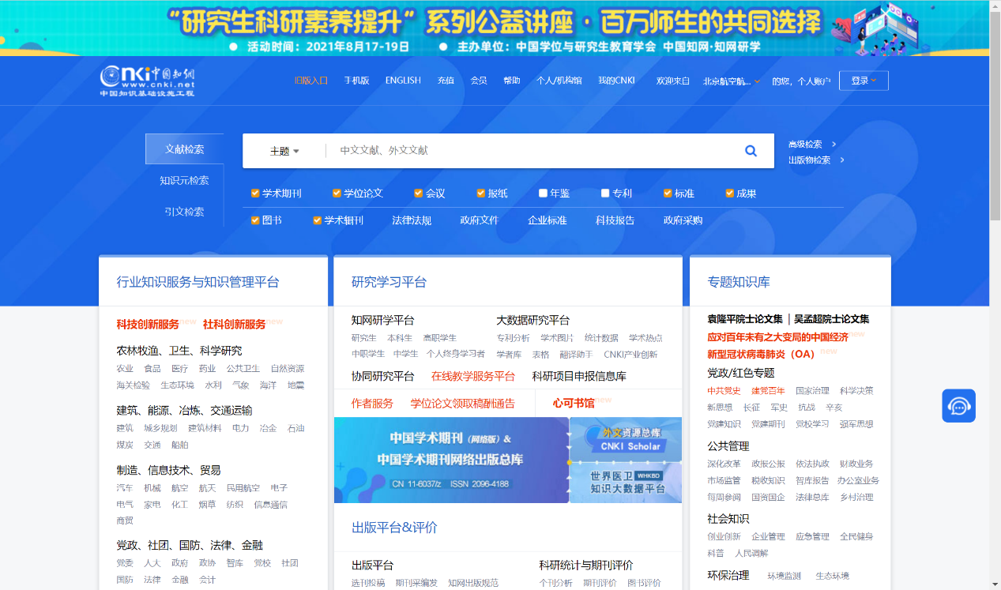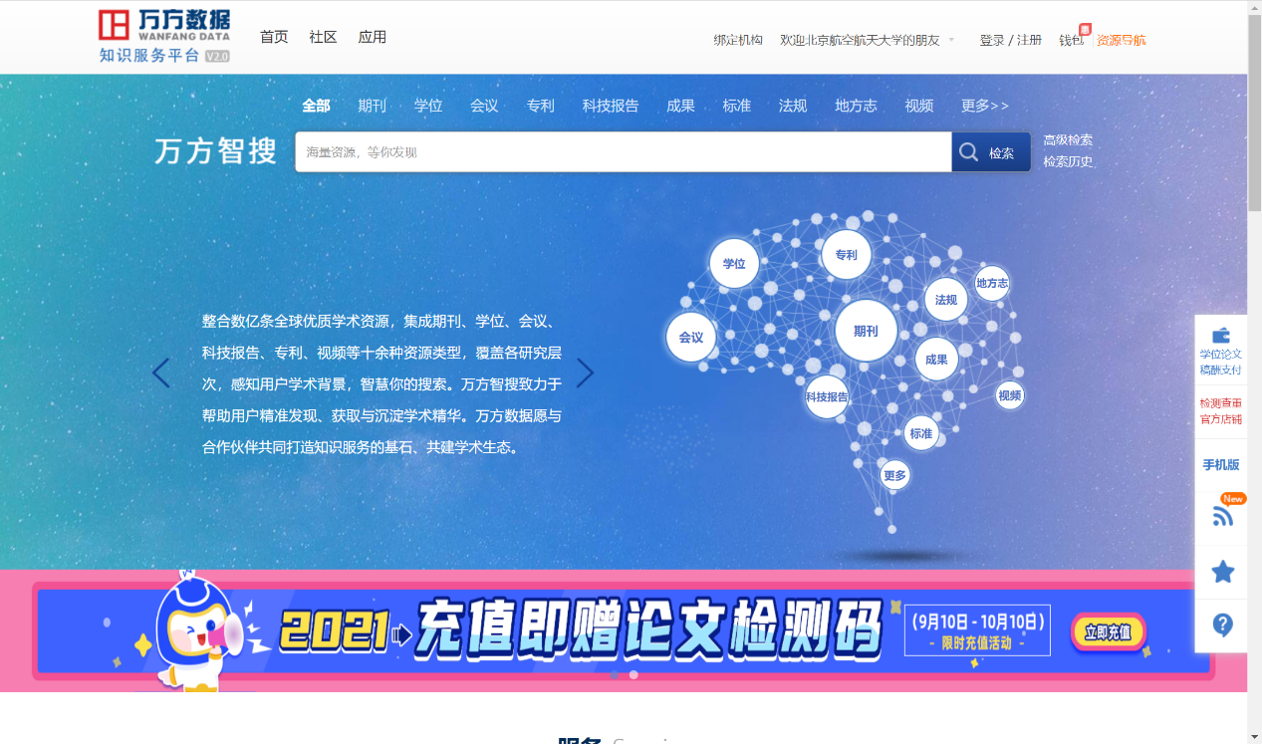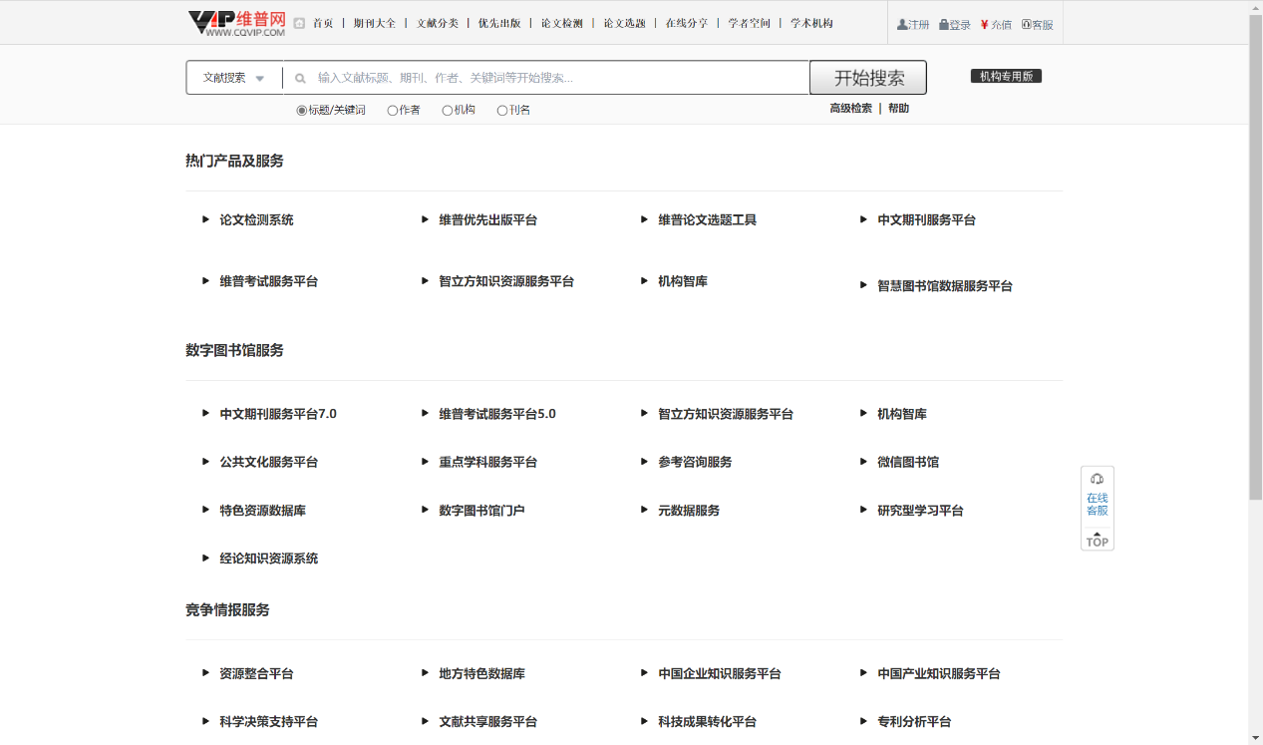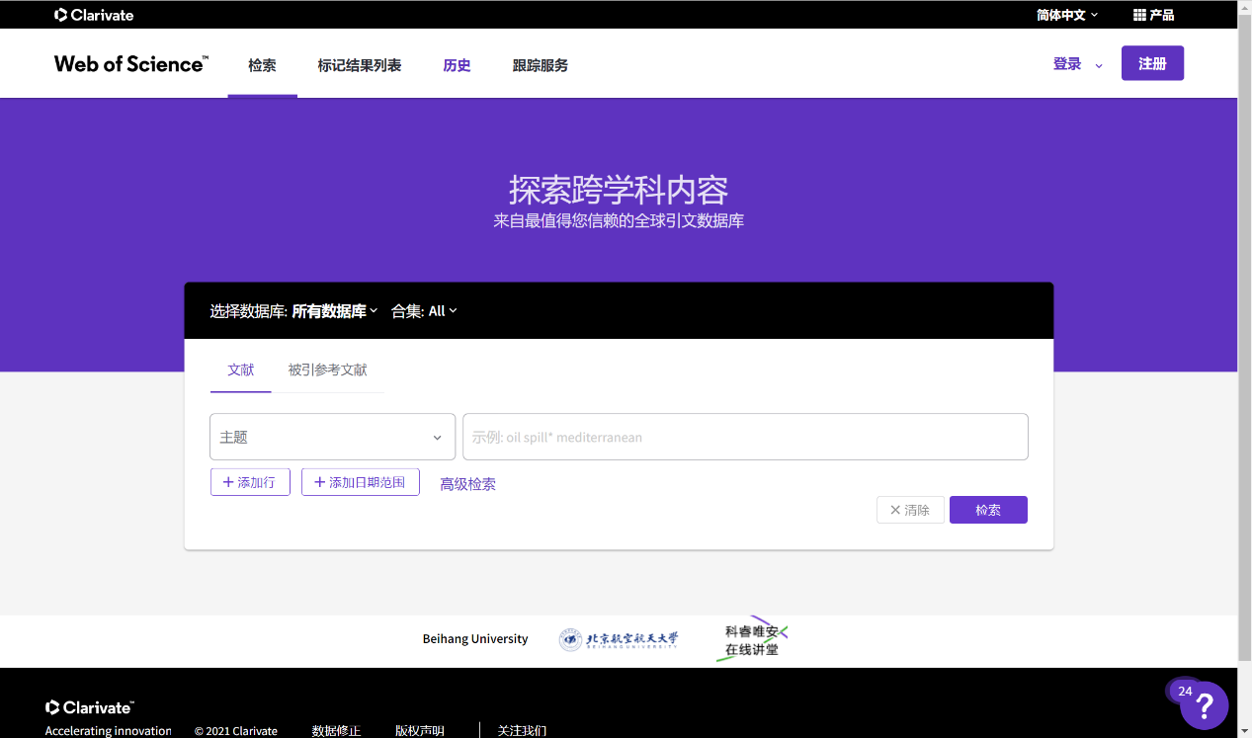

**18题的1、2、3、4分别指：**

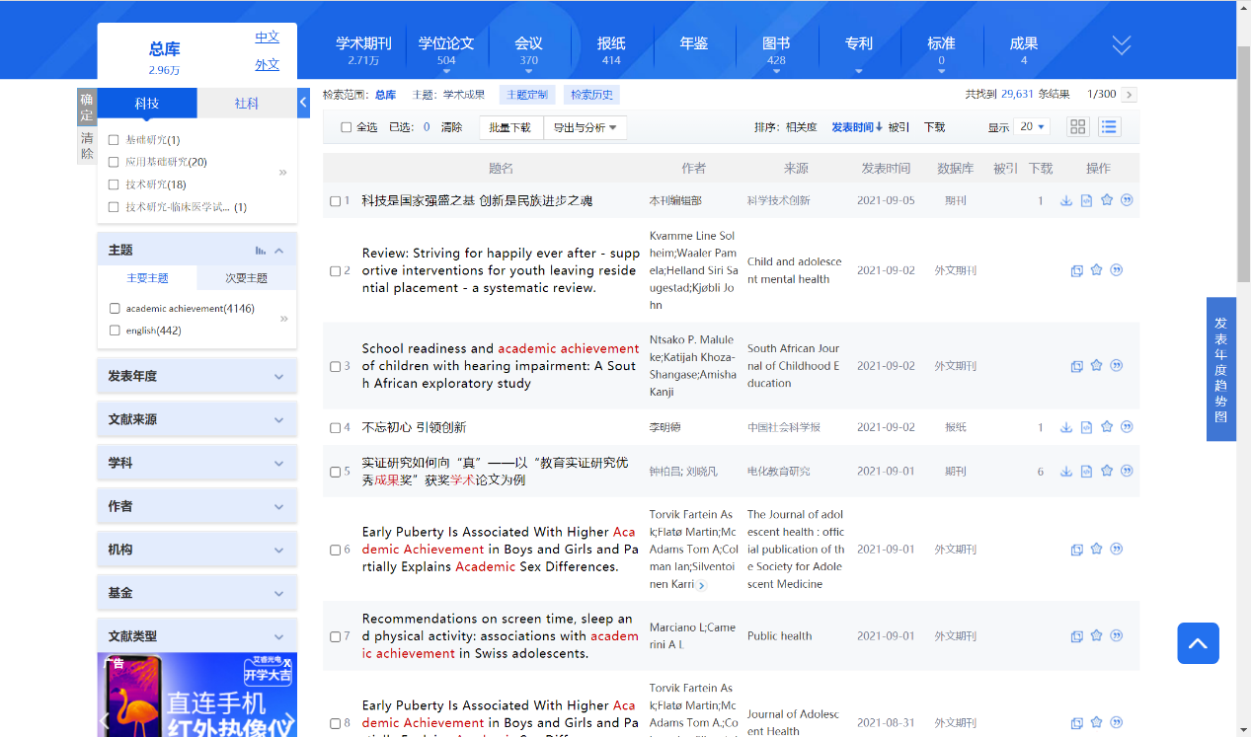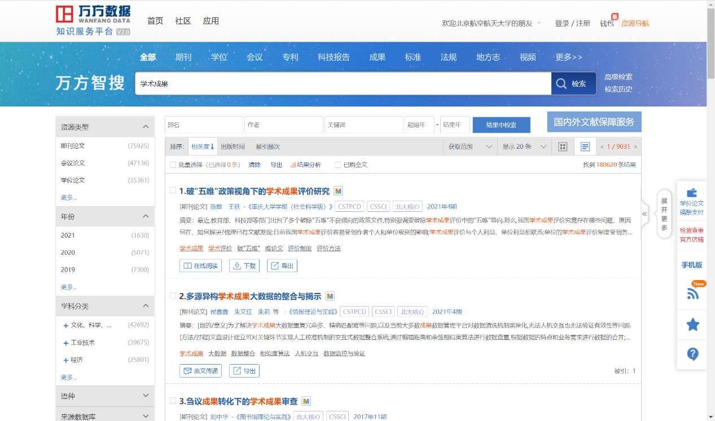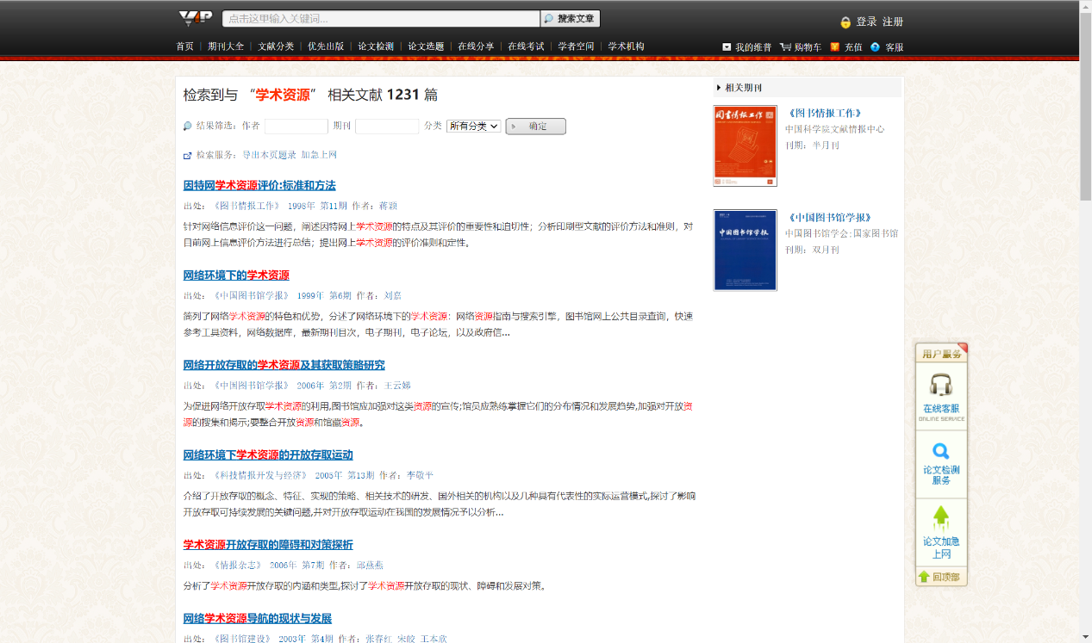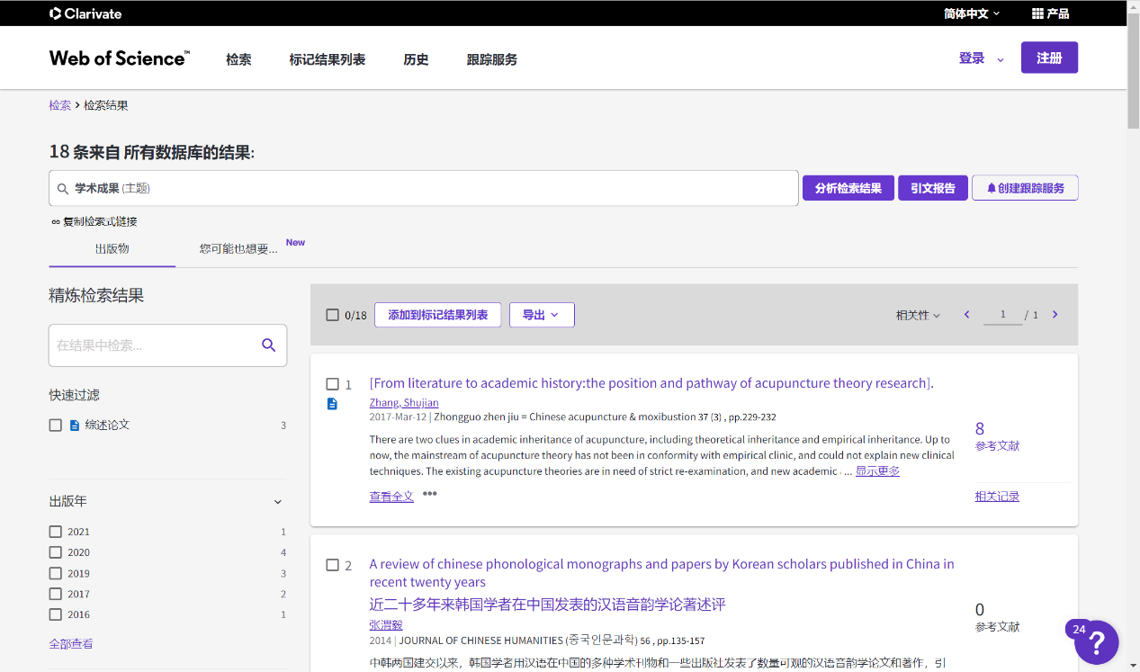

19题的1、2、3、4分别指：

